JAVA PRACTICE SHEET(26/01/26)
1.
Given an integer array arr[] and an integer k, your task is to find and return the kth smallest
element in the given array.
Note: The kth smallest element is determined based on the sorted order of the array.
Examples:
Input: arr[] = [10, 5, 4, 3, 48, 6, 2, 33, 53, 10], k = 4
Output: 5
Explanation: 4th smallest element in the given array is 5.
Input: arr[] = [7, 10, 4, 3, 20, 15], k = 3
Output: 7
Explanation: 3rd smallest element in the given array is 7.
Constraints:
1 ≤ arr.size() ≤ 105
1 ≤ arr[i] ≤ 105
1 ≤ k ≤ arr.size()
Sol
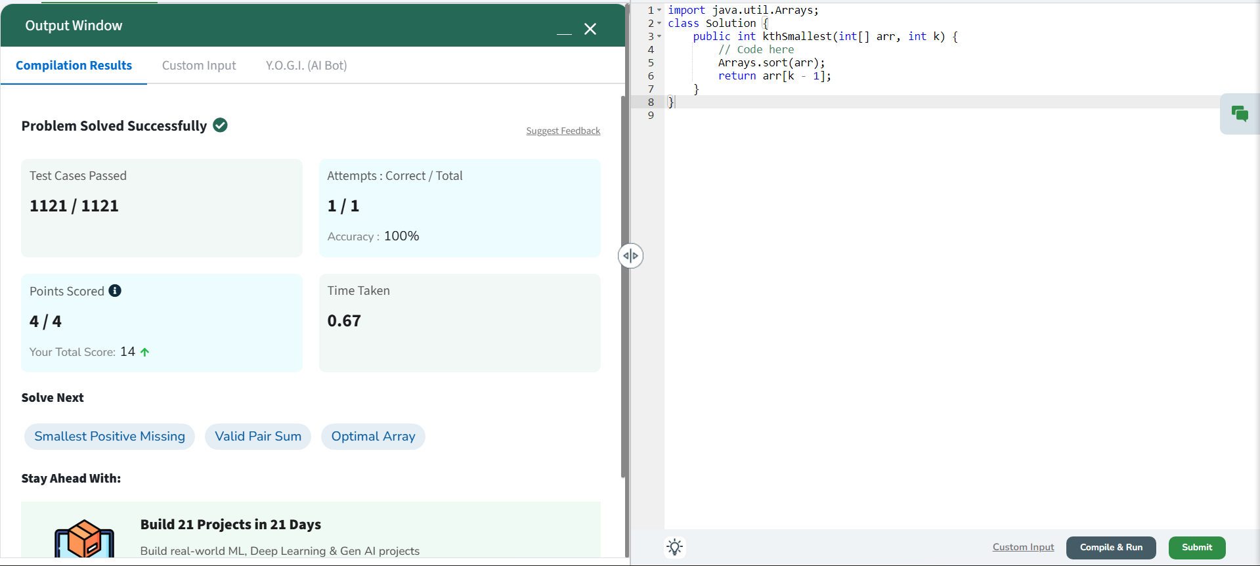
2.
Given an array arr[] denoting heights of n towers and a positive integer k.
For each tower, you must perform exactly one of the following operations exactly once.
Increase the height of the tower by k
Decrease the height of the tower by k
Find out the minimum possible difference between the height of the shortest and tallest towers
after you have modified each tower.
You can find a slight modification of the problem here.
Note: It is compulsory to increase or decrease the height by k for each tower. After the operation,
the resultant array should not contain any negative integers.
Examples :
Input: k = 2, arr[] = [1, 5, 8, 10]
Output: 5
Explanation: The array can be modified as [1+k, 5-k, 8-k, 10-k] = [3, 3, 6, 8]. The difference
between the largest and the smallest is 8-3 = 5.
Input: k = 3, arr[] = [3, 9, 12, 16, 20]
Output: 11
Explanation: The array can be modified as [3+k, 9+k, 12-k, 16-k, 20-k] = [6, 12, 9, 13, 17]. The
difference between the largest and the smallest is 17-6 = 11.
Constraints
1 ≤ k ≤ 107
1 ≤ n ≤ 105
1 ≤ arr[i] ≤ 107
Sol
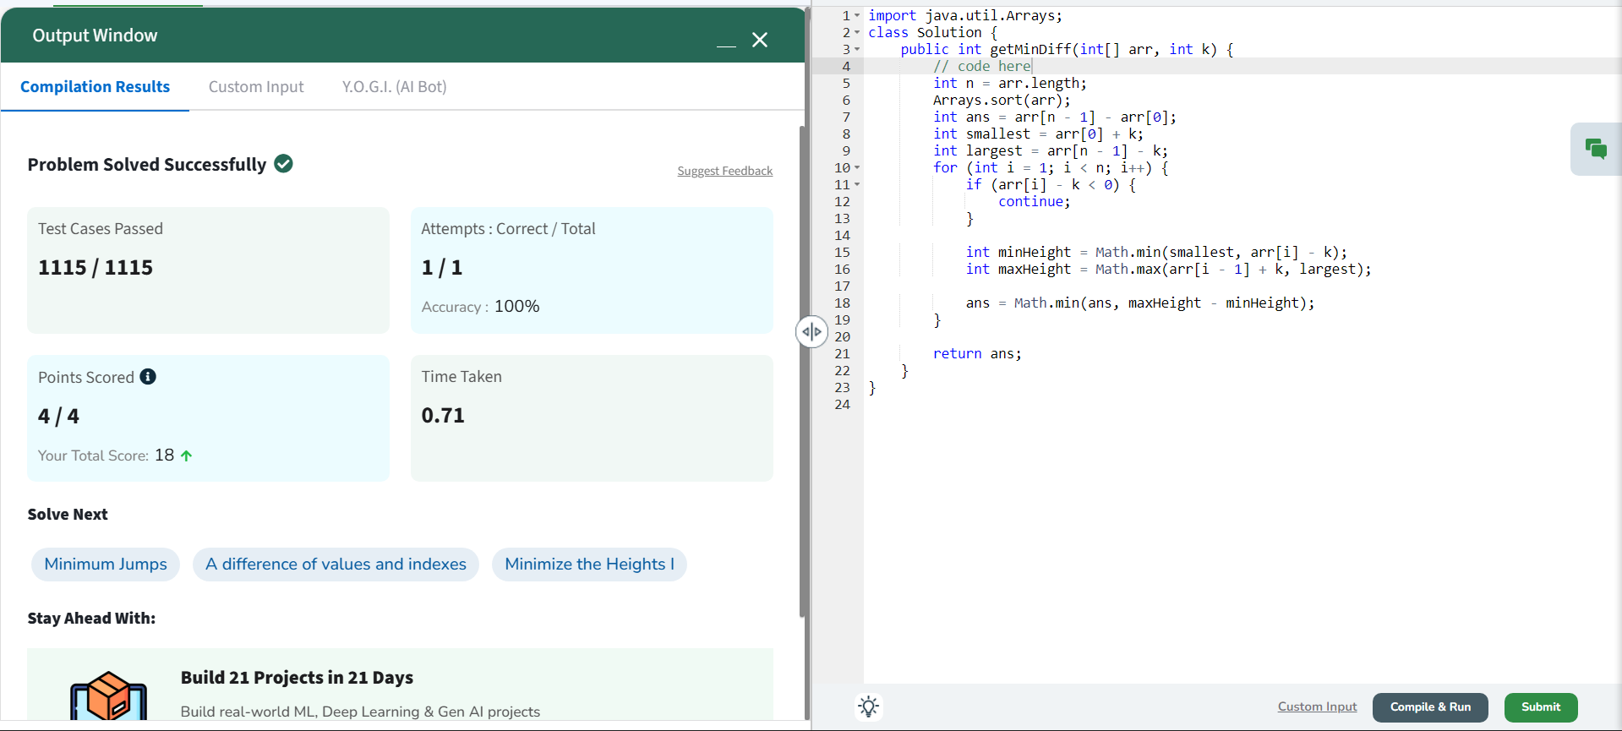
3.
You are given an array arr[] of non-negative numbers. Each number tells you the maximum
number of steps you can jump forward from that position.
For example:
If arr[i] = 3, you can jump to index i + 1, i + 2, or i + 3 from position i.
If arr[i] = 0, you cannot jump forward from that position.
Your task is to find the minimum number of jumps needed to move from the first position in the
array to the last position.
School of Computer Science and Engineering
Experiment List for Programming Ability and Logic Building - 1
Note: Return -1 if you can't reach the end of the array.
Examples :
Input: arr[] = [1, 3, 5, 8, 9, 2, 6, 7, 6, 8, 9]
Output: 3
Explanation: First jump from 1st element to 2nd element with value 3. From here we jump to 5th
element with value 9, and from here we will jump to the last.
Input: arr = [1, 4, 3, 2, 6, 7]
Output: 2
Explanation: First we jump from the 1st to 2nd element and then jump to the last element.
Input: arr = [0, 10, 20]
Output: -1
Explanation: We cannot go anywhere from the 1st element.
Constraints:
2 ≤ arr.size() ≤ 105
0 ≤ arr[i] ≤ 105
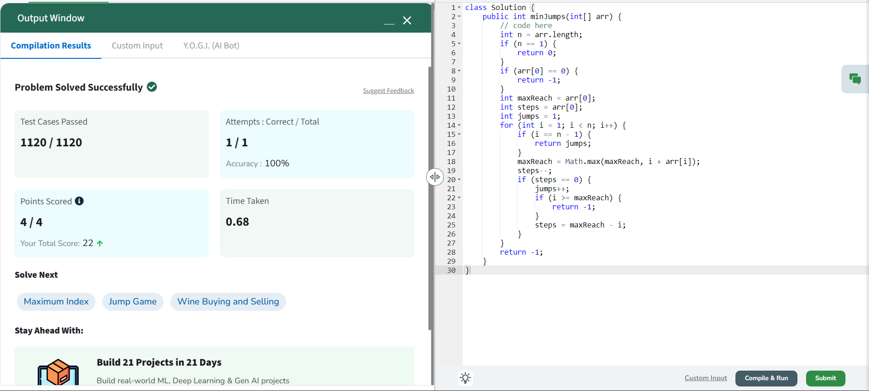
4.
Given an array of integers nums containing n + 1 integers where each integer is in the range [1, n]
inclusive.
There is only one repeated number in nums, return this repeated number.
You must solve the problem without modifying the array nums and using only constant extra
space.
Example 1:
Input: nums = [1,3,4,2,2]
Output: 2
Example 2:
Input: nums = [3,1,3,4,2]
Output: 3
Example 3:
Input: nums = [3,3,3,3,3]
Output: 3
Constraints:
1 <= n <= 105
nums.length == n + 1
1 <= nums[i] <= n
All the integers in nums appear only once except for precisely one integer which appears two or
more times.
Sol
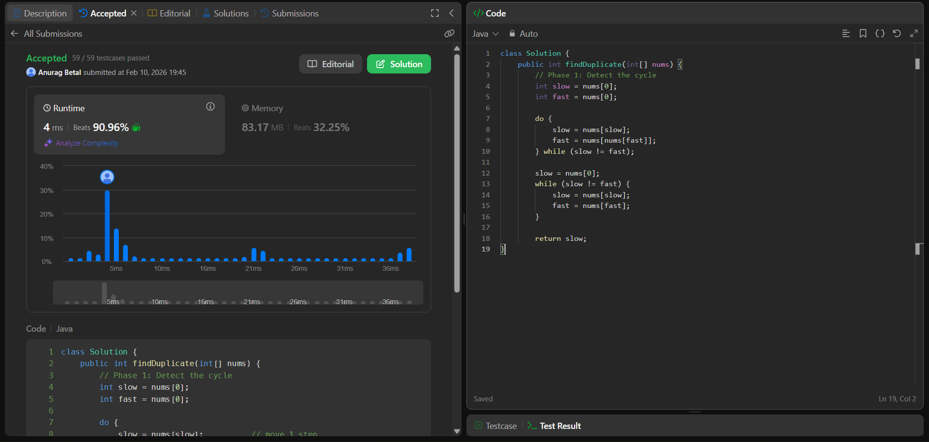
5.
Given two sorted arrays a[] and b[] of size n and m respectively, the task is to merge them in
sorted order without using any extra space. Modify a[] so that it contains the first n elements and
modify b[] so that it contains the last m elements.
Examples:
Input: a[] = [2, 4, 7, 10], b[] = [2, 3]
Output: a[] = [2, 2, 3, 4], b[] = [7, 10]
Explanation: After merging the two non-decreasing arrays, we get, [2, 2, 3, 4, 7, 10]
Input: a[] = [1, 5, 9, 10, 15, 20], b[] = [2, 3, 8, 13]
Output: a[] = [1, 2, 3, 5, 8, 9], b[] = [10, 13, 15, 20]
Explanation: After merging two sorted arrays we get [1, 2, 3, 5, 8, 9, 10, 13, 15, 20].
Input: a[] = [0, 1], b[] = [2, 3]
Output: a[] = [0, 1], b[] = [2, 3]
Explanation: After merging two sorted arrays we get [0, 1, 2, 3].
Constraints:
1 ≤ n, m ≤ 105
0 ≤ a[i], b[i] ≤ 10^7
Sol
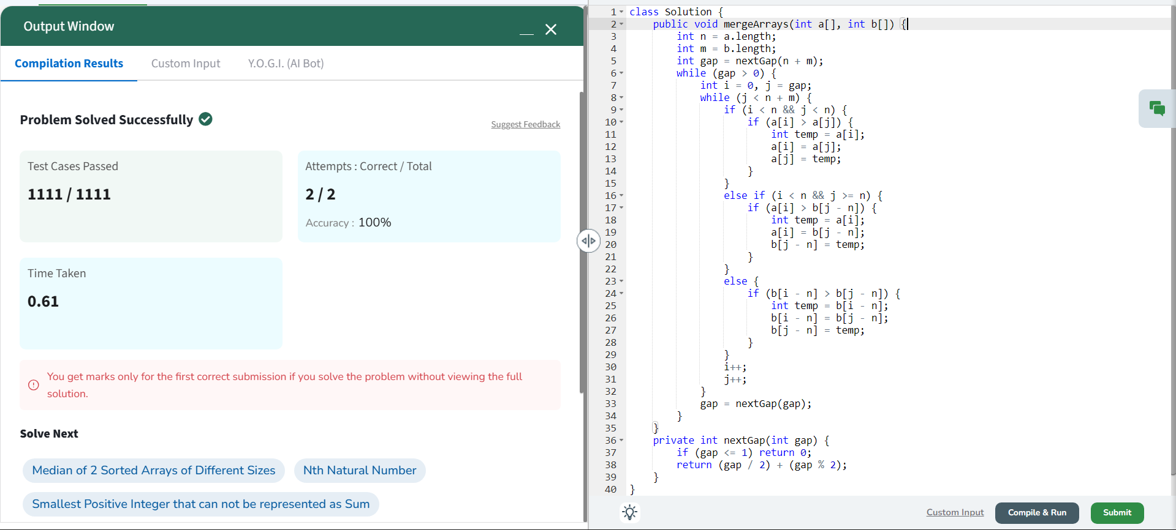
6.
Given an array of intervals where intervals[i] = [starti, endi], merge all
overlapping intervals, and return an array of the non-overlapping intervals that
cover all the intervals in the input.
Example 1:
Input: intervals = [[1,3],[2,6],[8,10],[15,18]]
Output: [[1,6],[8,10],[15,18]]
Explanation: Since intervals [1,3] and [2,6] overlap, merge them into [1,6].
Example 2:
Input: intervals = [[1,4],[4,5]]
Output: [[1,5]]
Explanation: Intervals [1,4] and [4,5] are considered overlapping.
Example 3:
Input: intervals = [[4,7],[1,4]]
Output: [[1,7]]
Explanation: Intervals [1,4] and [4,7] are considered overlapping.
Constraints:
1 <= intervals.length <= 10^4
intervals[i].length == 2
0 <= starti <= endi <= 10^4
Sol
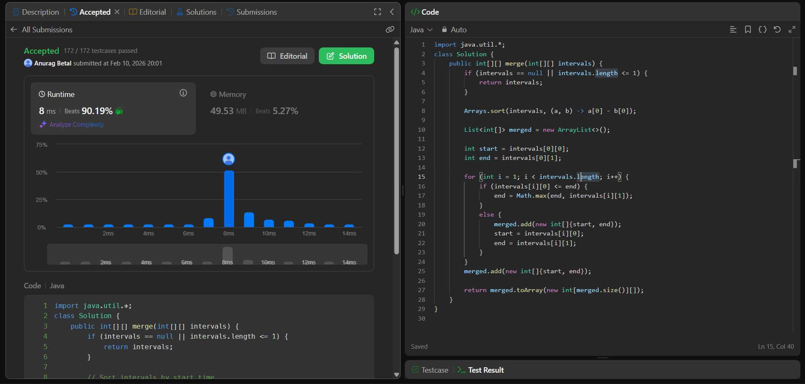
7.
Given three sorted arrays in non-decreasing order, print all common elements
in non-decreasing order across these arrays. If there are no such elements return
an empty array. In this case, the output will be -1.
Note: can you handle the duplicates without using any additional Data Structure?
Examples :
Input: arr1 = [1, 5, 10, 20, 40, 80] , arr2 = [6, 7, 20, 80, 100] , arr3 = [3, 4, 15, 20,
30, 70, 80, 120]
Output: [20, 80]
Explanation: 20 and 80 are the only common elements in arr1, arr2 and arr3.
Input: arr1 = [1, 2, 3, 4, 5] , arr2 = [6, 7] , arr3 = [8,9,10]
Output: [-1]
Explanation: There are no common elements in arr1, arr2 and arr3.
Input: arr1 = [1, 1, 1, 2, 2, 2], arr2 = [1, 1, 2, 2, 2], arr3 = [1, 1, 1, 1, 2, 2, 2, 2]
Output: [1, 2]
Explanation: We do not need to consider duplicates
Sol
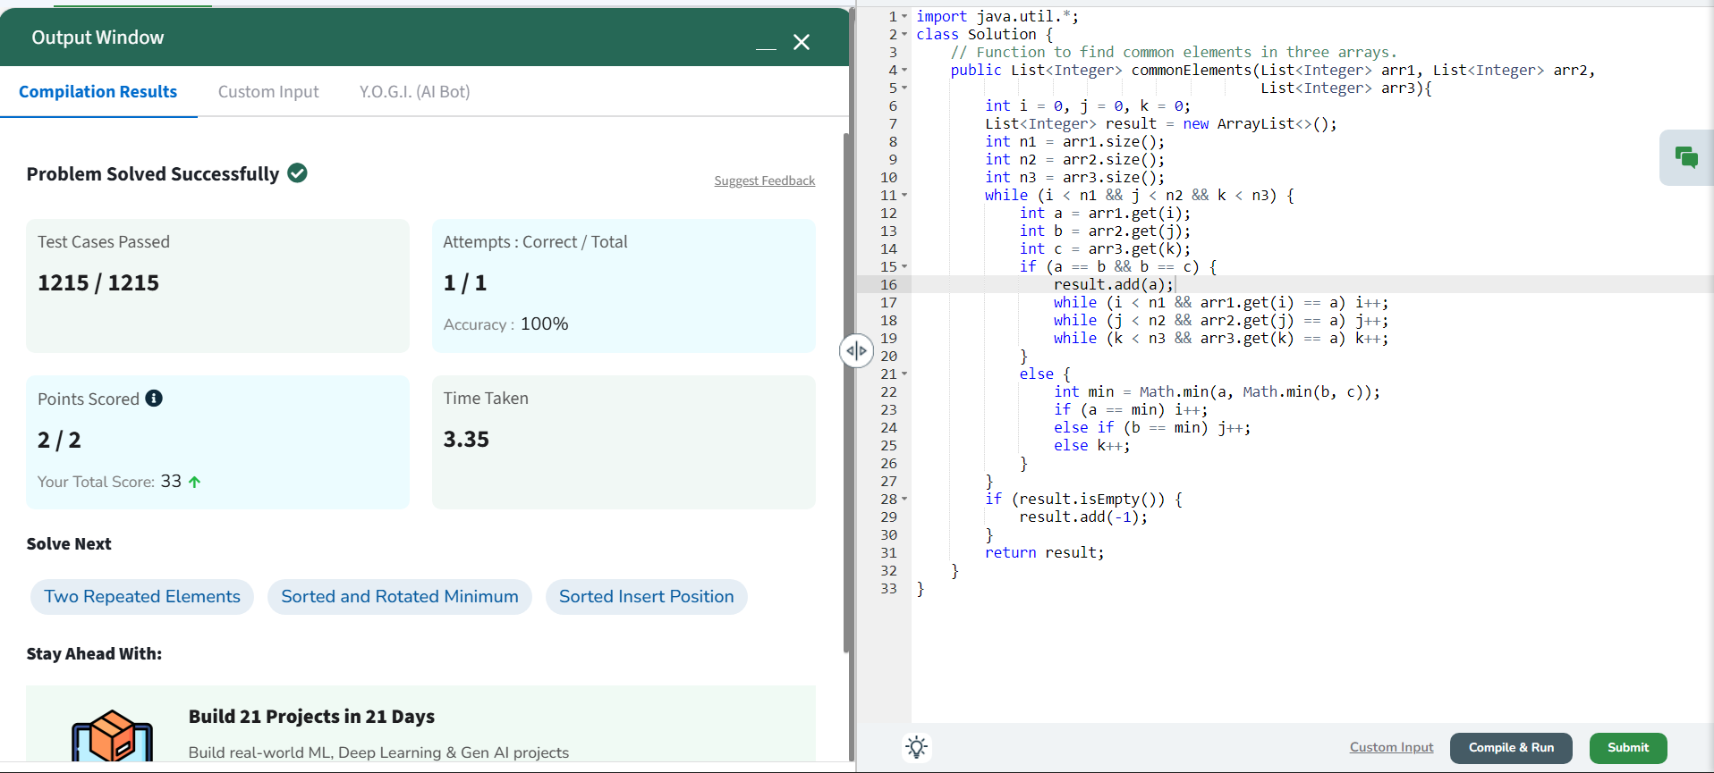
8.
Given an integer n, find its factorial. Return a list of integers denoting the digits
that make up the factorial of n.
Examples:
Input: n = 5
Output: [1, 2, 0]
Explanation: 5! = 1*2*3*4*5 = 120
Input: n = 10
Output: [3, 6, 2, 8, 8, 0, 0]
Explanation: 10! = 1*2*3*4*5*6*7*8*9*10 = 3628800
Input: n = 1
Output: [1]
Explanation: 1! = 1
Sol
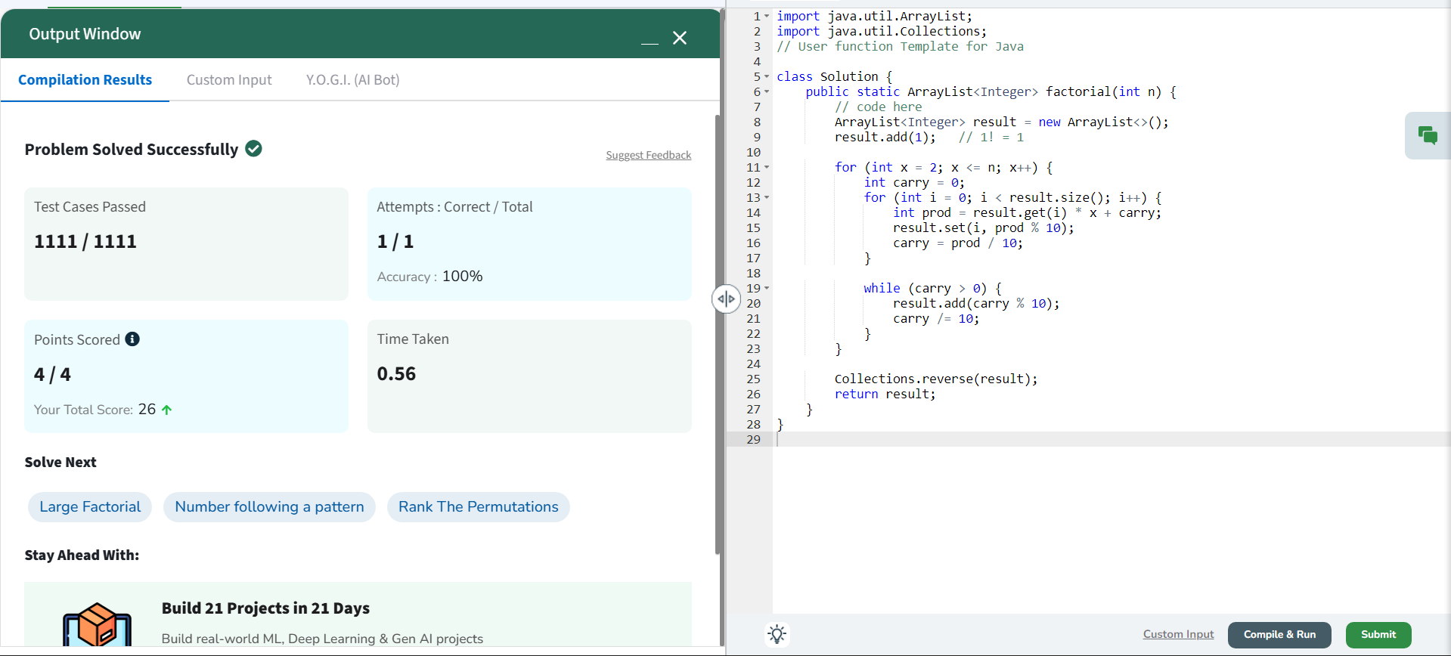
9.
Given two arrays a[] and b[], your task is to determine whether b[] is a subset
of a[].
Examples:
Input: a[] = [11, 7, 1, 13, 21, 3, 7, 3], b[] = [11, 3, 7, 1, 7]
Output: true
Explanation: b[] is a subset of a[]
Input: a[] = [1, 2, 3, 4, 4, 5, 6], b[] = [1, 2, 4]
Output: true
Explanation: b[] is a subset of a[]
Input: a[] = [10, 5, 2, 23, 19], b[] = [19, 5, 3]
Output: false
Explanation: b[] is not a subset of a[]
Sol
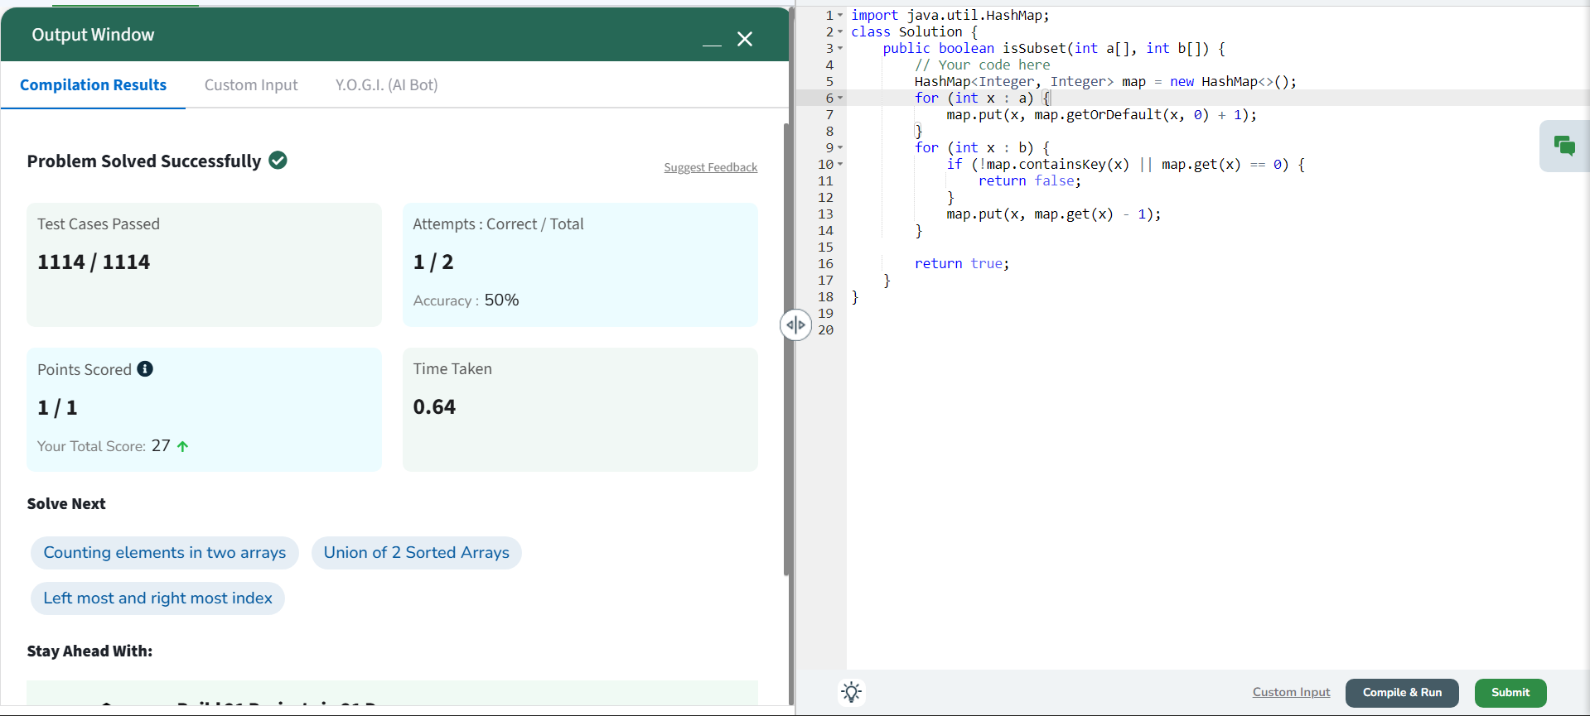
10.
Given an array arr[] and an integer target, determine if there exists a triplet in the
array whose sum equals the given target.
Return true if such a triplet exists, otherwise, return false.
Examples:
Input: arr[] = [1, 4, 45, 6, 10, 8], target = 13
Output: true
Explanation: The triplet {1, 4, 8} sums up to 13.
Input: arr[] = [1, 2, 4, 3, 6, 7], target = 10
Output: true
Explanation: The triplets {1, 3, 6} and {1, 2, 7} both sum to 10.
Input: arr[] = [40, 20, 10, 3, 6, 7], target = 24
Output: false
Explanation: No triplet in the array sums to 24.
Sol
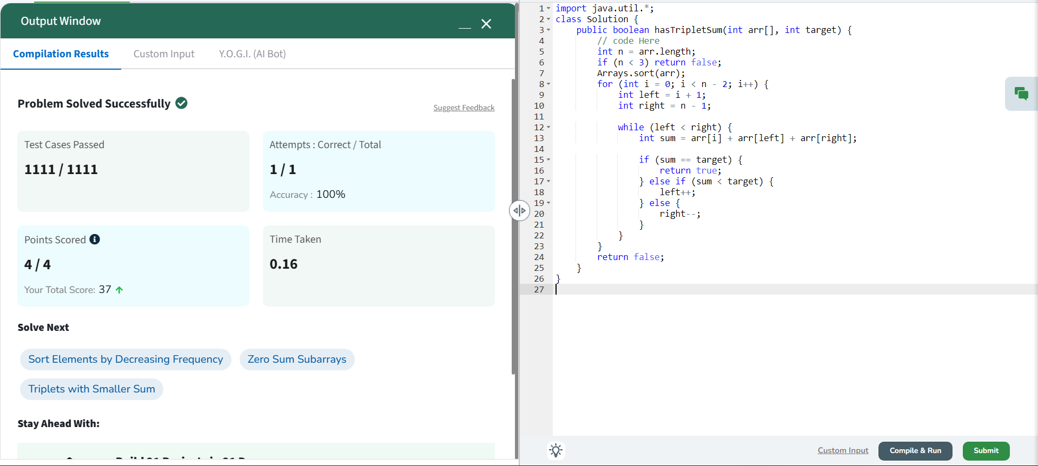
11.
Given an array arr[] with non-negative integers representing the height of blocks.
If the width of each block is 1, compute how much water can be trapped between
the blocks during the rainy season.
Examples:
Input: arr[] = [3, 0, 1, 0, 4, 0 2]
Output: 10
Explanation: Total water trapped = 0 + 3 + 2 + 3 + 0 + 2 + 0 = 10 units.
Input: arr[] = [3, 0, 2, 0, 4]
Output: 7
Explanation: Total water trapped = 0 + 3 + 1 + 3 + 0 = 7 units.
Input: arr[] = [1, 2, 3, 4]
Output: 0
Explanation: We cannot trap water as there is no height bound on both sides.
Input: arr[] = [2, 1, 5, 3, 1, 0, 4]
Output: 9
Explanation: Total water trapped = 0 + 1 + 0 + 1 + 3 + 4 + 0 = 9 units.
Sol
